Homework 6 (15 pts)[1]

1. [6 pts]: Perform an A* search to find the shortest path from San Franscisco to Atlanta in the attached graph. The first graph shows the distances between cities. The second graph shows the heuristic distances from each other city to Atlanta. Show your answer by filling out the table on the next page as done in Appendix A (and as shown in class on Feb 22).

This is a version of file F2b from Deliverable B, with some links removed, and the abbreviations reduced to one letter each.

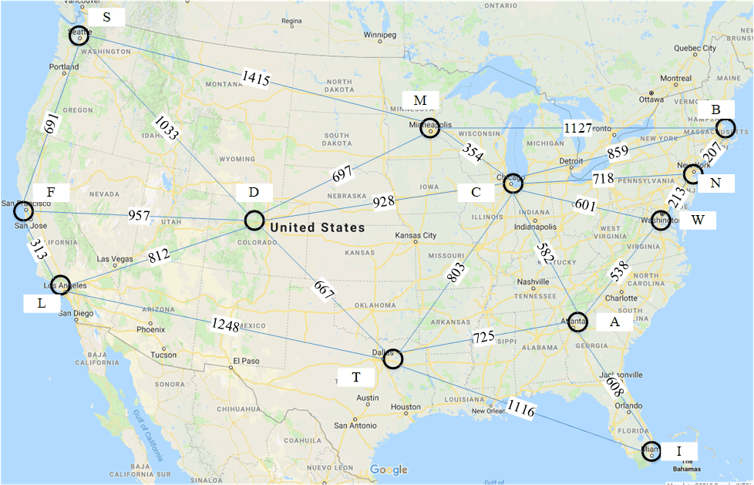

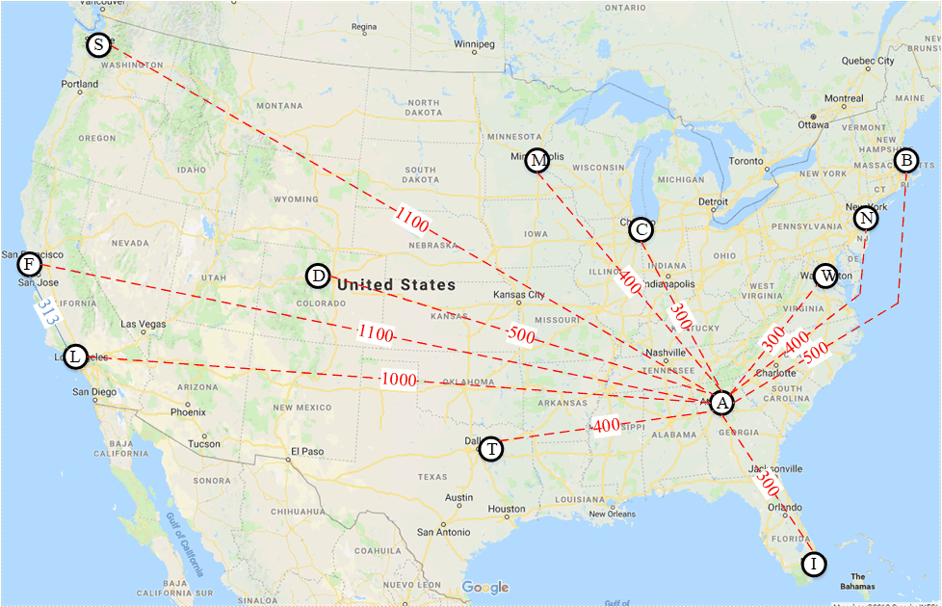

|  |  |  |  |  |  |  |  |  |  |  |  |  |  |  |  |
| --- | --- | --- | --- | --- | --- | --- | --- | --- | --- | --- | --- | --- | --- | --- | --- |
| Node | Priority Queue after Expanding Node (only 1st pos fixed) | | | | | | | | | | | | | | |
| node | f | path | node | f | path | node | f | path | node | f | path | node | f | path |
| F | L | 1313 | FL | D | 1457 | FD | S | 1791 | FS |  |  |  |  |  |  |
| L | D | 1457 | FD | S | 1791 | FS | T | 1961 | FLT |  |  |  |  |  |  |
| D | S | 1791 | FS | M | 2054 | FDM | C | 2185 | FDC | T | 1961 | FLT |  |  |  |
| S | T | 1961 | FLT | M | 2054 | FDM | C | 2185 | FDC |  |  |  |  |  |  |
| T | M | 2054 | FDM | C | 2185 | FDC | A | 2286 | FLT | I | 2977 | FLT |  |  |  |
| M | C | 2185 | FDC | A | 2286 | FLT | B | 3281 | FDM | I | 2977 | FLT |  |  |  |
| C | A | 2286 | FLT | B | 3244 | FDC | I | 2977 | FLT | W | 2786 | FDC | N | 3003 | FDC |
| A |  |  |  |  |  |  |  |  |  |  |  |  |  |  |  |

So the shortest path is F 🡪 L 🡪 T 🡪 A

(in terms of names, San Francisco 🡪 Los Angeles 🡪 Dallas 🡪 Atlanta)

1. [6 pts]: Iterative Deepening: SF 🡪 Atl. Using the same graph as above, Perform an iterative deepening heuristic depth first search (H-DFS w/ID) to locate a path from San Francisco to Atlanta. Stop when you find the first path. Whenever you have a choice of two or more nodes to visit, visit the nearer node. Begin searching at a depth of one node. Deepen the search by one node each time. Print the nodes visited as shown in Appendix B for each depth of search (depth 1, depth 2, and depth 3). ***See Appendix B.***



***Comment:***

There are at least two different ways to look at iterative deepening. One way, if you’re just searching for a path to a node, is that if you’ve already visited a node, you won’t go back there, even you find it at a shallower level. The other way is that you will revisit nodes at a shallower level to try to find the shortest path. I’ll accept either answer. So I give two solutions.

***Solution 1:*** *(don’t revisit already-visited nodes)*

Depth 1 search:

F

|

L S D

Depth 2 search: *(comment: there is no place I can get to from Seattle (S) or Los Angeles (L) that I cannot also get to from Denver, so I don’t expand Denver. I’m not looking for the shortest path here.)*  
F

|

L S

| |

D T M

Depth 3 search:

F

|

L S

|

D

|

T M C

Depth 4 search:

F

|

L

|

D

|

T

|

A

Path: F L D T A

***Solution 2***: Revisit nodes

Depth 1 search:

F

|

L S D

Depth 2 search: *(comment: I revisited nodes, if you don’t revisit a node at a deeper level than you’ve already seen it, that’s OK)*  
F

|

L S D

| | |

D T D M T M L C S

Depth 3 search:

F

|

L

|

D T

| |

T M C S D A

First solution found: FLTA

1. [6 pts]: Prove that a linear combination of admissible, consistent heuristics is an admissible, consistent heuristic. That is, if h1(n) and h2(n) are heuristics, then prove that for any a in the open interval (0,1):
   * Part A: Prove h(n) = ah1(n) + (1-a)h2(n) is admissible.
   * Part B: Prove h(n) = ah1(n) + (1-a)h2(n) is consistent.

***Solution:***

Define d(a,b) as the actual distance between nodes a and b. In particular, d(n,g) is the actual distance between any node n and the goal node g.

Part A:

A heuristic h is an admissible heuristic if h(n) ≤ d(n,g) for all n.

h1 is an admissible heuristic, so h1(n) ≤ d(n,g) for all n.

h2 is an admissible heuristic, so h2(n) ≤ d(n,g) for all n.

So h(n) = ah1(n) + (1-a)h2(n) ≤ ad(n,g) + (1-a)d(n,g) = d(n.g). So h is an admissible heuristic.

Part B :

A heuristic h is a consistent heuristic if for any two nodes n and n’, h(n) ≤ d(n,n’) + h(n’).

h1 is a consistent heuristic, so h1(n) ≤ d(n,n’) + h1(n’) for all n, n’.

h2 is a consistent heuristic, so h2(n) ≤ d(n,n’) + h2(n’) for all n, n’.

Thus h(n) = ah1(n) + (1-a)h2(n) ≤ a d(n,n’) + a h1(n’) + (1-a) d(n,n’) + (1-a) h2(n’) = d(n,n’) + h(n’)

**Appendix A: A* Search example**

|  |  |  |  |  |  |  |  |  |  |  |  |  |
| --- | --- | --- | --- | --- | --- | --- | --- | --- | --- | --- | --- | --- |
| node | Priority queue after expanding node (only 1st pos fixed) | | | | | | | | | | | |
| Node | f | path | Node | f | path | Node | f | path | Node | f | path |
| S | A | 5 | S | B | 5 | S |  |  |  |  |  |  |
| A | B | 5 | S | C | 8 | SA | D | 8 | SA |  |  |  |
| B | E | 7 | SB | C | 8 | SA | D | 8 | SA | F | 10 | SB |
| E | C | 8 | SA | D | 8 | SA | G | 8 | SBE | F | 10 | SB |
| C | D | 8 | SA | G | 8 | SBE | F | 10 | SB |  |  |  |
| D | G | 8 | SBE | F | 10 | SB |  |  |  |  |  |  |
| G |  |  |  |  |  |  |  |  |  |  |  |  |

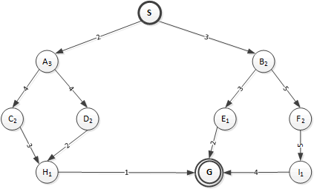

**Appendix B: Heuristic Depth First Search with Iterative Deepening (H-DFS w/ID) example**

L

let’s take the same file that you will be using, but we will do the H-DFS w/ID from Minneapolis (M) to Miami (I). I list the nodes in the order in which I discover them.



Depth 1 search: (1st row is node at depth 0, second row is nodes at depth 1)

M

C D B S

Depth 2 search: (added row is nodes at depth 2, under the node they were discovered from, so A W N T B and D were discovered from C, and F was discovered from S)

M

C S

A W N T B D F

Depth 3 search: (added row is nodes at depth 3, we stop when we discover F the goal)

M

C

A

W I

Path: M C A I

1. Note that > 15 points are possible, so basically this homework includes a little extra credit.